## Student Learning and Outcomes

Sample District’s performance indicator for student learning and outcomes states:

*In line with national standards, all students are able to synthesize and develop knowledge and express their ideas creatively using and producing a variety of media. Students are proficient in basic technology skills and are information and media literate. They are able to acquire knowledge through research and technology, and take ownership of their own learning, collaborate and problem solve with others, while exploring different perspectives utilizing a variety of instructional technology tools within a personalized learning environment.*

This indicator logically breaks down into three broad categories of analysis:

* Student use of and proficiency in basic technology skills
* Student technology use aligned with national standards (NETS)
* Students taking ownership over their learning in a personalized learning environment

### Student Technology Proficiency

The evaluators gathered data on student technology proficiency by querying teachers and parents and by observing students working in their classrooms and other instructional environments. For example, teachers were surveyed as to their beliefs related to student technology skills. This data is shown in **Figure 8**, below. Here it can be seen that teachers mildly agree (i.e., the average falls between “neutral” and “agree”) that students “demonstrate proficiency with technology tools and operations appropriate to their grade level” (question 4d). On the other hand, teachers on average mildly disagree that students “arrive in my classroom each fall with the technology skills necessary to successfully use technology for learning”.

The evaluators observed students working with a wide variety of technology devices (workstations) throughout the district. In elementary schools, there is considerable use of iPads to create presentations (PowerPoint) and iBooks, and to access a wide variety of computer-based-instruction (CBI) programs for basic skills development. For example:

*I did an iBook with my kids. They record and I do the typing.*

*Students use technology to create original works and products (e.g., movies, presentations, digital media, stories and artwork to support thematic units.*

*math games are used to help children learn math facts, counting and alphabet games are used to support our phonics and fundation program*

*Using the iPads as Math stations at times allows them to do this more frequently.*

*RESEARCHING INFORMATION TO ADD FACTS TO THEIR NON FICTION UNIT OF STUDY // TYPING THIER OWN POEMS TO CREATE A POETRY BOOK // USING ROSETTA STONE TO ENHANCE THIER LANGUAGE SKILLS // USING RAZ KIDS TO IMPROVE THIER READING SKILLS*

Parents echo these examples by providing similar information about their students’ use of technology in school.

*Writing homework letters. Navigating Google Docs. Doing homework. Playing math games. Playing various educational games. Completing "Pearson Success Net" assignments. Working with "Type to Learn". Accessing and using many more sites.*

*I was very impressed that my 3rd grader was able to create his own power point presentation.*

*Most meaningful experience has been during Challenge camp where my daughter learned how to tell stories through powerpoint. She uses the ipad at school to play math games which she enjoys.*

*Educational applications on the iPads and programs such as Castle Learning on the school computers for Math and ELA.*

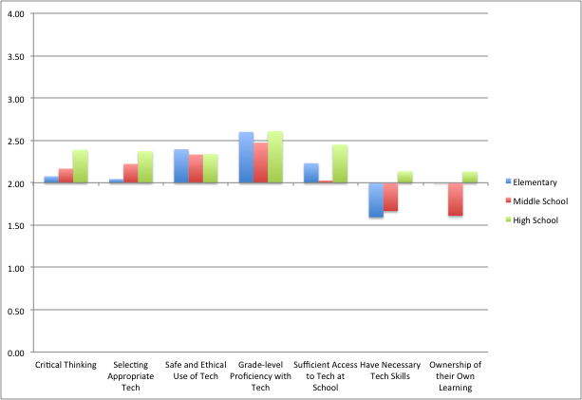

**Figure 8** – Teacher belief statements, survey questions 4a – 4g. 4 = Strongly Agree, 3 = Agree, 2 = Neutral, 1 = Disagree, 0 = Strongly Disagree

At the secondary level, the evaluators observed and heard about very similar student uses of technology. Once again, there seems to be a very often-noted use of PowerPoint for presentations. There is also frequent mention of students using online information. In the classroom, secondary students seem to make frequent use of classroom laptop carts. Many carts were observed by evaluators throughout the high school and middle school buildings. Examples of secondary student technology use cited by Sample District teachers, administrators and parents include:

*We use technology with our group projects – Google docs allows our students to collaborate. Lots of teachers come to the library to use Google Docs.*

*We use iPads in math classes for student groups to create presentations for the class.*

*There is actually very little in the classroom that doesn’t use technology – student presentations are done using the Smartboard and students use laptops to put their presentations on the Smartboard.*

*We have clickers that can be used wih the Smartboard to get quick responses from students about how well they understand the lesson.*

*Simulated online labs like gel electrophoresis and DNA extraction*

*Students created original news productions on events in the Roman Empire. They varied from taping their productions to using powerpoint to support an in class presentation.*

In short, the evaluators find that Sample District students at all levels frequently use, and are thus familiar, with basic technology tools.[1] Overall, it appears that the Sample District elementary students begin to use basic productivity applications – notably PowerPoint – at an early age to produce work product. From elementary school onward, students have access to technology devices and seem to use them routinely throughout their K-12 career in the district. At the high school, the evaluators observed numerous classes where students utilized classroom carts of laptops to type papers.

#### Information and Media Literacy

One particular student skill that is called out in the district’s Student Skills and Outcomes indicator is information and media literacy.[2] The indicator states that students should be “*information and media literate…and they are able to acquire knowledge through research and technology*.”

The evaluators find that Sample District teachers at all levels K-12 state that students participate in “research”. For example elementary teachers note:

*Students can use technology to research information and then create a presentation to present what they have learned.*

*Students can conduct online research and evaluate whether websites are appropriate*

*A student could be given an idea/topic to develop and be given choices as to how to go about creating a project i.e. making a Smartboard Presentation, Slide Show and then research, develop and present to the class*

*A student can do a research project on a specific topic and then create an iBook on the iPad to later present to the class. They can type the information, add pictures, and voice over their writing. I have used this with my students and they are excited to create projects using technology.*

*An example would be if a student was interested in a topic, that student could use technology to find our more information about that topic, or to research the answer to a question.*

Similar examples exist in secondary teacher data.

*Sometimes if students create a question in class that no one knows the answer in. I will give bonus points if they can do research using technology to find the answer to share with the class.*

*I encourage all of my students to continue to ask questions related to our classroom lessons and go home to research on their own. They have extra assignments that can be turned in that focus on this "home research" idea.*

*Researching databases provide opportunities for students to safely research and thoughtfully respond to questions/projects that require research*

*Students have become familiar with several online encyclopedias and periodicals that the library has subscriptions that improve their research skills.*

*Students can choose the type(s) of technology tools that work best for their personal learning styles, for example, online research instead of "book" research.*

It is clear from teacher comments that assigning “research” is understood by most Sample District teachers as yet another way to differentiate student learning. Still, there is concern that not all students have the information and media literacy skills to be able to conduct effective research on their own. The question here is whether students can think critically about the information they encounter and thereby make appropriate decisions as to the validity and usefulness of online information. As the NETS-S Standard 3 – Research and Information Fluency – states, students have achieved this standard/have information and media fluency when they are able to:

* Plan strategies to guide inquiry
* Locate, organize, analyze, evaluate, synthesize, and ethically use information from a variety of sources and media
* Evaluate and select information sources and digital tools based on the appropriateness to specific tasks
* Process data and report results[3]

In regard to these fluencies, the evaluators find that a number of Sample District teachers and parents have concerns as to whether their students are able to effectively perform all of these tasks. As teachers noted:

*It’s all about Google. They have no idea how to use another search engine. We talk about Wikipedia and how it’s not so factual. This year we have not taught research skills at all.*

*We talk about plagerism and how it’s wrong to copy from a website. It usually comes after they get caught.*

*I think the majority of our students feel that any content on www is legitimate*

*Well, at the high school they seem to know the difference between legitimate and not so valid resources. I think there is a difference in maturity between the ms and hs and even between regents and honors students*

*My concern is that students do not read well enough to wallow through the mire of the internet. They are always in a hurry to get to the one answer even if one answer is not what is being asked. I am also concerned that keyboarding skills are not being reinforced and that students are slowing down because they do not know how to type correctly. Not enough emphasis is being put on reading and many of the teachers at the high school level do not have expectations or knowledge or time to teach the students how to correctly research a question/idea/topic.*

As the above quotes show, a number of teachers (and parents) are concerned that students do not receive instruction in information literacy. It appears that this sort of instruction traditionally falls in the domain of the school librarian.

*In the library there are projects where a class comes in and we direct them to specific sites and discuss how to evaluate sites - try to make a point that using a database for research is best because it's written by an expert and is fact-checked*

While the librarian is indeed praised for work in this area, it is nevertheless the case that some schools do not have librarians or therefore any specific way of addressing information literacy outside of instruction in the classroom.

*We used to have a librarian who taught them this, but we don’t have a librarian any more. We have a great TA who’s running the library, but she’s not a librarian*

*Students should receive formal classroom instruction in the use of different media available to them in school; such as, e-books, library databases, etc.*

Parents note that information literacy and digital citizenship are subjects that ideally should be covered in the classroom.

*Aside from safe practices in using the internet (which I have taught my child, since school does not seem to provide this) I wish the teachers could help develop the awareness of a wide range of tools, sites, techniques, that will help her be on the appropriate level for a 21st century learner.*

*[I would like to see] more instruction about how to assess information safely and properly*

The evaluators note that in the classroom, information and media literacy should theoretically be closely aligned with the teaching of critical thinking, although it is often the case that teachers do not make this connection. As shown in **Figure 8**, above, Sample District teachers are largely neutral in terms of their belief that their students “demonstrate critical thinking skills by evaluating and selecting appropriate information resources” (question 4a). Likewise, as will be discussed further below, Sample District teachers typically only assign instructional tasks where students use “digital tools to gather information and conduct research” (Figure 6, question 2d) less than “several times a semester”. Therefore, the evaluators find that while many teachers reference the idea of media and information literacy as relating to research, the actual frequency with which these tasks are assigned is actually rather infrequent.

### Student Technology Use Aligned with NETS

As shown in **Figure 9**, Sample District teachers on average report that they engage their students in various activities supportive of NETS-S-related skills “several times a semester”. This average holds true across grade levels, with generally higher rates seen at the secondary level. Parent data (**Figure 10**) essentially confirms the teacher data.

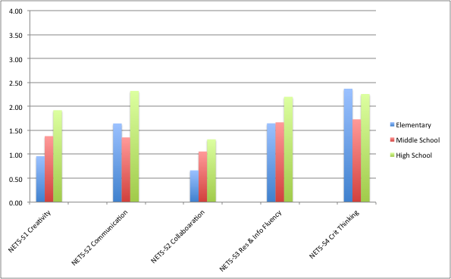

**Figure 9** - Teacher responses to online survey question 2, about the frequency with which they use technology to perform and inspire various instructional (student) tasks. For analysis, these tasks are then mapped to NETS-S standards. Scale: 0 = Never, 1 = Several times a year, 2 = Several times a semester, 3 = Two or three times a month, 4 = At least once a week.

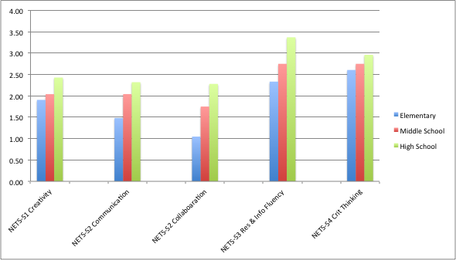

**Figure 10** – Parent responses to online survey question 2, about the frequency with which students use technology to perform and inspire various instructional (student) tasks. For analysis, these tasks are then mapped to NETS-S standards. Scale: 0 = Never, 1 = Several times a year, 2 = Several times a semester, 3 = Two or three times a month, 4 = At least once a week.

The evaluators’ observation and interview data also confirms the survey data through the variety and frequency with which specific NETS-S-generative activities were reported and observed. Typical teacher comments/examples of these instructional activities include:

*In 3rd we study countries. So last year for Brasil they worked in teams to present on differnet sets of countries. Lots of critical thinking and collab.*

*In a nutshell, the technology that is available for helping us learn to analyze, read, and perform music is used by every professional musician. In today's world, a musician can (1) hear how a song is played (Youtube), (2) use software to aide them in recognizing their mistakes (Smart Music), (3) record their playing(Garage Band) to accurately assess their progress, and (4) share what they have done (Internet). As young musicians, we strive to emulate the top players, even if it is scaled down to fit our level of playing.*

*[We] SKYPE with students and teachers in other districts and/or locations.*

*[We] Skype, Face-time with other grades/countries*

The evaluators note that some teachers wrote speculatively about what they would use technology. For example:

*I would love to use technology in the classroom. I think technology can assists in building authentic learning connections to real life applications, it can promote creativity, it promote social skills, it can help concepts not be so compartmentalized and brdige that gap between the classroom and real world.*

*I would like to see students communicating with science professionals, maybe even some distance labs that stduents can complete guided by researchers involved in projects with larger scopes. It would be great to have presenters that could communicate online and databases that students can add to, allowing them to contribute to long-term projects related to genetics or ecology. I am already using the computer for simulated online labs that are too expensive or time-consuing to do in the classroom.*

In each of these (immediately) above examples from the online teacher survey, the secondary school respondents provided Question 2 frequency of use responses indicating that they seldom to never use technology in ways that support NETS-S. Barriers cited were as follows:

*I am very interested in improving techonology use in TUFSD but we need a technology leader/director to set the course for the district to take us into the 21st century and beyond.*

*There should be more common training provided maybe on staff days where several options for technology use/new technologies canbe explored based on what a teacher might require*

In later sections of this chapter, there will be further discussion about the barriers and challenges Sample District’s teachers face in implementing the kinds of instructional environments that support NETS. Nevertheless, it is clear to the evaluators that the vast majority of the student technology use that occurs in Sample District classrooms (and outside of school on school-related work) is more centered around basic productivity tasks than it is generative of higher order thinking and learning skills such as those described by NETS.

For example, of the over 110 classroom observations conducted by the evaluators, only 10 involved any student hands-on use of technology, and in nearly all of those cases the students were simply using the computers for typing, creating presentations, or working on skills re-enforcement apps/programs. Survey data again supports this point about how Sample District students are using technology. As seen in **Figure 11**, the term “PowerPoint” (and the related term “presentation”) was the most frequently used term in teacher survey responses describing both what their “ideal” use of technology would be as well as what their students are currently doing with technology. Following this is “Google Docs” which is mostly described by teachers (in context within the data) as being a way for students to create documents and “turn in work” online.[4] Note how these terms very much over-shadow terms and concepts such as simulation or “collaborate”. These terms *are* used by some teachers to describe activities such as science simulations or student-to-student collaborations, but the terms, and therefore the activities they represent, are rare.

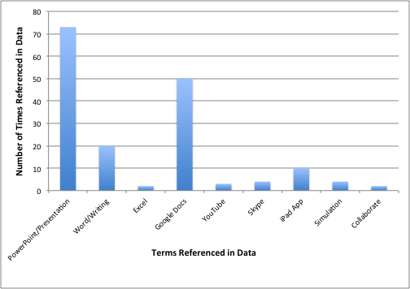

**Figure 11** – Frequency of specific terms and concepts appearing in teacher survey data describing the “ideal” (Question 1) and actual (Question 2) uses of technology within their classrooms.

Clearly it is the case that most Sample District students do indeed have hands-on exposure to technology in school, but it is equally clear from the survey and interview data that the vast majority of student technology work relates to teacher-directed use of technology to access information and to produce work product.

### Ownership Over Learning and Personalized Learning Environment

Sample District’s Student Skills and Outcomes indicator describes students who

*…take ownership of their own learning…utilizing a variety of instructional technology tools within a personalized learning environment.*

To determine the extent to which this is occurring, the evaluators posed a variety of questions to district teachers, administrators and parents. Not only have the evaluators asked teachers and parents whether or not they agree that students have taken ownership over their own learning, but the evaluators have also sought to determine what the common definition of “ownership over learning” might be.

**Figure 8**, discussed earlier in this chapter, shows teacher responses to survey question 4g where teachers were asked if they agreed that their students currently have ownership over their own learning. **Figure 12**, below, shows parent data for the same question (3g in the Parent survey). As can be seen, while most Sample District teachers and parents were more or less neutral in their opinions on this question, teachers were less in agreement that students have ownership than are parents. Parents on average mildly agree that students do have ownership.

### 

**Figure 12** – Parent agreement with belief statements, survey questions 3a – 3h. 4 = Strongly Agree, 3 = Agree, 2 = Neutral, 1 = Disagree, 0 = Strongly Disagree

The evaluators asked teachers and parents for examples of what they understand “ownership over learning” to mean. Typical teacher definitions are:

*Students can use technology in multiple ways to take ownership of their own learning. With the use of technology, students have access to an abundance of information that is relevant to their educational needs. In addition, they can use a wide variety of educational applications or programs to enhance their understanding of confusing concepts. Students can individualize their instruction by using technology to self-differentiate learning and focus on areas that may need additional support.*

*A student can do a research project on a specific topic and then create an iBook on the iPad to later present to the class. They can type the information, add pictures, and voice over their writing. I have used this with my students and they are excited to create projects using technology.*

*When the student is asked to research an animal as part of a genre study and the teacher allows the student to either use books or the internet to gather more information.*

*Students can use ipads or accessible websites at home to help internalize and reinforce skills taught in school.*

*Pearson (our Math Envisions program) provides the chance for the teacher to assign and track individual students. I can give them remediation work, enrichment, or assign review. There are also assessments and games. Each child has his/her own account and logs on weekly.*

*That there are tiered levels of additional practice concepts from one level to the next level. Also, that opportunities for struggling students are available for multiple practice experiences until success is achieved.*

*A struggling student could access the many opportunities that technology provides to fill in voids and gaps, while an advanced student could do the same for enrichment purposes*

As these teacher comments show, the most common definition for what it means for a student to take ownership over his/her learning is that the student is able to utilize technology to access different types and levels of material according to his/her needs or interests. In this regard, the definition is very much related to teachers’ belief that the primary value in utilizing technology within the classroom is in support of “differentiation” (this will be discussed further in the Teacher Skills and Pedagogy indicator below).

Many parents provided similar examples:

*My daughter's teacher gives her appropriate options so that she can make choices and feels empowered over what she is learning.*

*If a student does not understand what was taught in school they can look up a tutorial on the computer and go through the process of understanding how it is done, at their own pace.*

Despite the consistency of most teacher and parent definitions, several teachers and parents did express an idea that is more about student agency and direction. In other words, student-centered learning:[5]

*A student could easily do this through the creation of an independent study project, where the topic was selected by the child (with teacher guidance as needed). If a child is fully engaged in learning, he/she will be very motivated to investigate a topic of his/her choosing. The child could be guided by teaching staff to develop a worthwhile research question to investigate, and he/she should set up a timeline for completion of various components of the independent study.*

*The internet provides us with the ability to extend learning and go beyond what is being placed in front of our students. It teaches students early on how to critically evaluate and prioritize their thoughts in order to synthesize what they are looking for and grasp their exact goal in researching topics.*

*A student could use technology to take ownership over their own learning by using it to further their studies of something learned in school. Through the internet (on reliable websites) children now have so much information at their fingertips. Technology helps students to feel empowered.*

*They can watch videos of lessons (flipped classroom) and then develop questions based on what they have seen instead of being "fed" information by a teacher. They can try different activities at different levels based on current understanding and they can increase the level of difficulty as their learning increases.*

Several teachers indicate that while it might be desirable for students to take ownership, this is not possible given a variety of restrictions to access.

*I love the flipped classroom. I would like to assign a short video for them to review at home. Then the class time would be spent working problems that stem from the video or rely on the information in the video. I can't do this in SHHS because many of my children do not have access to technology outside of school.*

*I feel that our students do not have appropriate access to do certain types of research. Our system manages to block a majority of the sites needed within our field of study.*

*Teachers can use for demonstration purposes, but students rarely have a chance to do exploration on their own. The computer labs are usually reserved for science classes and select social studies classes.*

Other teachers, while discussing the concept of student ownership over learning, noted that they question whether their students are doing this due to what these teachers perceive of as a lack of student ability to transfer skills and knowledge. These teachers noted that students are learning how to use particular technologies for the purposes they are provided (e.g., producing assigned work product) but that they do not necessarily choose to apply these skills to other thinking, learning or life tasks. For example:

*I don’t think that technology is playing a huge part other than learning how to navigate the iPad and iPhone. I don’t have kids going home and saying ‘let’s make an imovie’. Are they becoming more tech savvy?*

This comment points to what the evaluators again find to be a very limited and largely teacher-directed orientation to much of Sample District’s instructional environment. Students are indeed provided with multiple ways to address their learning needs, but these “ways” are prescribed by teachers. Even when the “teacher” is in fact a computer – as is the case in a CBI interaction – students are more channeled than would ideally be the case in an educational environment where there was a high degree of student ownership over the learning process.

Ownership over learning is a concept that most Sample District teachers tie to another idea expressed by Sample District’s indicator – that is, the “personalized learning environment”. Here teachers typically define such an environment as:

*My definition of a personalized learning environment is one where the individual's learning styles are accented so the individual can utilize resources that benefit his or her learning.*

*A place where a student can find success with tasks that are appropriate for their needs.*

*My definition of a "personalized learning environment" is one that supports the individual learning MODALITY of a particular student.*

*Each child has their own learning style (Gardner). As I am able to assess how a child learns, I personalize their learning environment to work on their weaknesses and accent their strengths.*

*A learning environment where differentiation is present and actively pursued.*

In short, Sample District teachers define a personalized learning environment as yet something else that results from differentiation.

So, given these definitions, to what extent do Sample District’s students use a variety of technologies (take ownership over their learning) within a learning environment that is the result of differentiation (a personalized learning environment)? The evaluators unfortunately find that this ideal – as defined by Sample District teachers – is actually seldom met. Most technology use by Sample District’s students is very much teacher directed and relates to simply producing work product or development of basic skills. To the extent that students are able to interact with some basic skills development CBI software – e.g., Castle Learning, RazKids, Math Envisions, Study Island, etc. – “at their own pace” and to develop different levels of skills, then technology is supporting differentiation; but CBI is still very teacher-directed and is not an environment where students truly exercise choice. “Multiple choice” is not choice in the sense of a true student-centered learning environment where choice (and therefore ownership) is defined as involving and encouraging “divergent reasoning, problem solving, and critical thinking”.[6] Therefore, the evaluators find that Sample District students are only meeting a very narrow interpretation of the spirit of the district’s indicator for Student Skills and Outcomes.

1. An exception to this, which will be discussed later in this chapter in relation to “K-12 Technology Integration Map” is typing and keyboarding.
2. The evaluators note that this is also a NETS-S skill.
3. ISTE NETS and Performance Indicators for Students (NETS-S). Standard 3. 2007.
4. Some secondary teachers do note the collaborative benefits Google Docs brings to student work, but this is a connection that is largely restricted to secondary teachers. Further discussion of Google Docs and collaboration will come later in this chapter.
5. For an excellent overview of the concepts and premises behind student-centered learning, and how this goes beyond simply providing resources matched at different student ability levels, see Hannafin and Land (1997) “The foundations and assumptions of technology-enhanced student-centered learning environments”. This article is available online at <http://nrega.nic.in/writereaddata%5CLabour_budget%5Clb_0314001001_1213.pdf>
6. ibid